# 

# 

# 

# 

# 

# 

# 

# CO326

# Computer Systems Engineering: Industrial Networks

# 

# **Smart Building Project:**

# **Group F (Photovoltaic System)**

| E/17/144 | Denuka Jayaweera |
| --- | --- |
| E/17/405 | Lahiru Wijesinghe |
| E/17/058 | Isuri Devindi |
| E/17/190 | Sashini Liyanage |
| E/17/369 | Savindu Wannigama |
| E/17/251 | Sandun Perera |
| E/17/331 | Sathira Silva |
| E/17/194 | Madhushan Ramalingam |
| E/17/090 | Achintha Harshamal |

# 

# Content

1. Introduction **3**

2. System Overview **4**

3. Hardware Implementation **6**

3.1 PV Panel 7

3.2 MPPT Charge Controller 8

3.3 DC to AC converter 9

3.4 Battery Pack 10

4. SCADA System **11**

4.1 Data Acquisition 11

4.2 Network Data Communication 12

4.3 Database 14

4.4 SCADA UI Controls 16

4.5 Data Visualization 17

4.6 Data Analysis 17

5. Prototype Design and Implementation **18**

5.1 Sensors 18

5.2 Actuators 19

5.3 Battery Pack Simulation 22

5.4 Implementation of Charge Controller 23

**6. References** **26**

# 1. Introduction

PV system is a renewable energy system which converts solar power into electricity using photovoltaic cells. Usage of PV systems in the modern constructions are seen because it provides a greener,sustainable and low maintenance system to the building.

PV converts solar energy into DC electricity, then that generated energy should be converted into AC electricity using an inverter. Photovoltaic systems generally consist of six individual components: the solar PV array, a charge controller, a battery bank, an inverter, a utility meter, and an electric grid. The correct installation of all of these components determines how efficient the solar panels are. Even though solar PV arrays produce power when they are exposed to sunlight, the other components are required for properly converting, distributing, and storing the energy that has been produced by the solar panels. The most typical PV panel system is the grid-connected system, which as its name indicates, is connected to the national grid. This means that at night, when the solar panels do not work, you can use electricity from the grid.

This report will go through the high-level implementation of a PV system which is controlled and managed using a SCADA system along with a prototype design of the proposed system.

# 2. System Overview

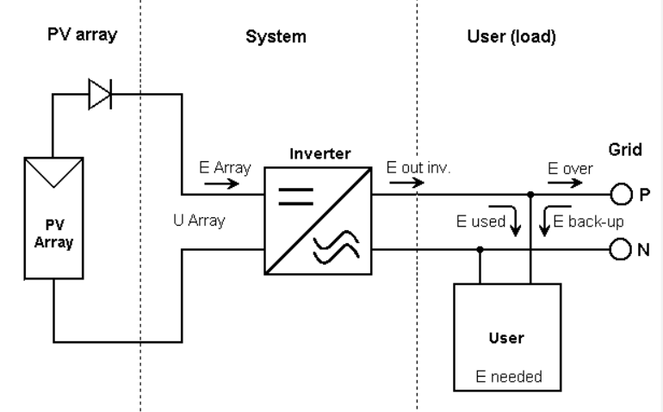

Figure 1: Simplified system diagram

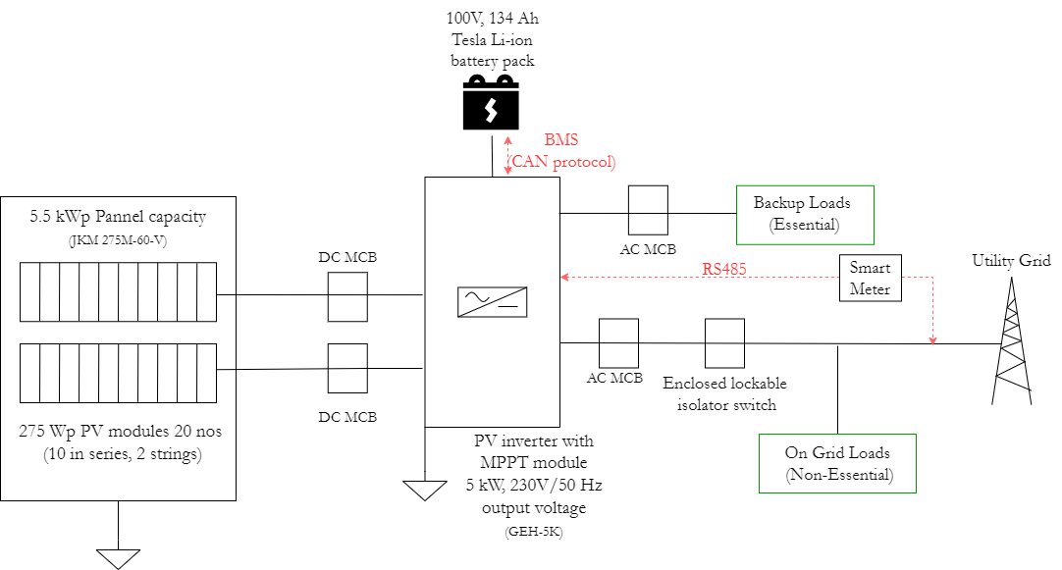

Figure 2: High level system design

PV panels are used to convert irradiance into DC electricity, then that generated energy should be converted into AC electricity using an inverter. Photovoltaic systems generally consist of six individual components: the solar PV array, a charge controller, a battery bank, a converter, a utility meter, and an electric grid. Even though solar PV arrays produce power when they are exposed to sunlight, the other components are required for properly converting, distributing, and storing the energy that has been produced by the solar panels.

Following are the main components in the system and their functionality.

1. PV modules (JKM275PP-60 260-275 Watt poly crystalline PV module from Jinko solar): 20 PV modules of 275 Wp each to generate a total of 5.5 kWp power. The conversion of irradiance to DC voltage is done in the solar cells.
2. The 5kW hybrid PV inverter with the built-in MPPT module (GEH-5K single phase hybrid inverter from GESolar): Following are the tasks done by the hybrid inverter.
   1. **Power regulation and maximization**: Charge the Li-ion battery with a constant current and voltage using the power generated by the PV pannels with the help of the MPPT charge controller module.
   2. **DC-to-AC power conversion**: Invert DC electricity that’s stored in the solar battery storage into 230V / 50 Hz AC electricity.
   3. **Source switching**: Provide a limited level of backup power using the battery incase of a main grid disconnection.
3. Battery pack (Tesla Li-ion battery): The energy generated by the PV modules are directly stored in the battery by the inverter and are used for consumption if the battery power is enough to supply power to the essential loads powered by the battery.
4. Smart meter: Used to communicate the grid power consumption to the SCADA system via the RS485 communication interface residing in the hybrid inverter.
5. AC and DC circuit breakers: Used as surge protectors and isolate the components from each other.
6. Enclosed lockable isolator switch: Used to ensure that the grid connection is completely de-energized for service or maintenance of the system.

# 3. Hardware Implementation

Figure 3: System Connection Diagram

The main hardware components in the system are as follows.

1. PV panel
2. MPPT charge controller
3. DC to AC converter
4. Battery Pack

The components residing inside the hybrid inverter are implemented separately as the MPPT charge controller, DC to AC converter, and the switch used to toggle between grid power and battery. Further details on these components are elaborated in the next few subsections.

## 3.1 PV Panel

PV panels are made out of semiconducting material and there are mainly three types of domestic panels; monocrystalline, polycrystalline, and thin-film. The photovoltaic cells that are connected together in a solar panel capture the sun’s energy and convert irradiance into DC electricity. Fixed tilt arrays are used for simpler and cheaper installation, and less maintenance.The arrays are fixed to tilt away from the horizontal plane to maximize the annual irradiation they receive.

The PV panel specifications used for the proposed system below were calculated considering the maximum power generation of 5.0 kW.

PV panel specifications (based on the PV array characteristics in figure 4 )

1. Product: Eagle 60M 275-295 Watt mono crystalline module - JKM275M-60V
2. Plane irradiance: 1000 W/m2
3. Operating Temperature: -40C to +85C
4. Maximum Output Power: 275Wp
5. Maximum Output Voltage: 31.6V
6. Maximum Output Current: 8.71A
7. Number of modules used to get 5.0kW: 20 (2 strings, 10 modules in series)
8. Array nominal power: 5.5 kWp
9. Estimated module area: 33 m2

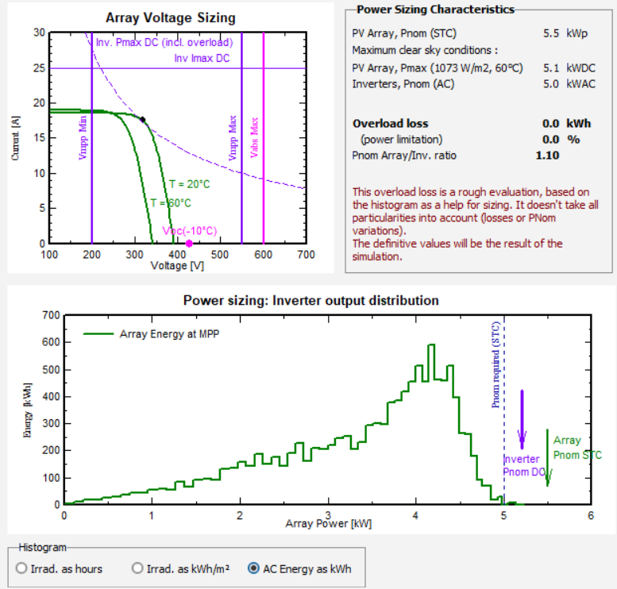

Figure 4: PV array characteristics

## 3.2 MPPT Charge Controller

The MPPT charge controller is used to charge the battery pack with constant current and voltage from the energy supplied from the PV modules. The non-linearity characteristics of solar cells (figure 4) pose a major challenge to harness the maximum power from the solar energy as they highly depend on solar irradiance, temperature and load. Based on the fluctuation of irradiance and temperature, the voltage and current continually vary the expected maximum output power from the PV system. To overcome the hindrance of nonlinearity, PV panels must be operated at maximum power point (MPP) under varying atmospheric circumstances. Solar charge controller (SCC) with MPPT consists of DC-DC Converter and MPPT algorithm. It utilizes the output of the PV panel (i.e., the voltage and current) to produce the pulse width modulation (PWM) signal to control the boost converter’s output. MPPT-SCC can transfer more than 90% of the PV panel power to the battery. To connect a battery with a different operating voltage in comparison to the MPP of the panel, a buck converter must be used in the circuit and to automatically identify the MPP of the panel, an MPPT algorithm is used in the system.

The heart of MPPT hardware is a DC-DC converter. Normally a DC-DC converter offers a constant source of power for change in line or load condition but it can also be used to track unique points by MPPT algorithm. MPPT uses the same converter for a different purpose to regulate the PV panel input voltage at knee point by use of a defined MPPT algorithm.

Figure 5 : Pertube and Observe algorithm to track the MPPT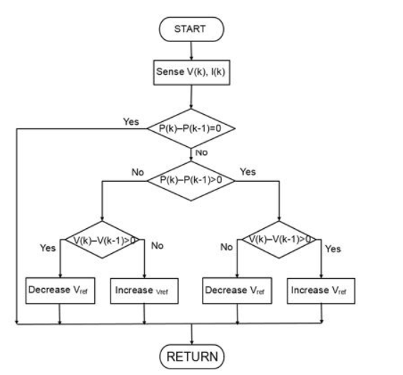

Among several techniques to track the MPP, the perturb and observe P&O algorithm is popular for its simplicity and high efficiency (figure 5 ) . The process involves slightly increasing or decreasing (perturbing) the operating voltage of a panel. Perturbing the panel voltage is accomplished by changing the duty cycle of the converter. Assuming that the panel voltage has been slightly increased and that this leads to an increase in the panel power, then another perturbation in the same direction is performed. If the increase in the panel voltage decreases the panel power, then a perturbation in the negative direction is done to slightly lower the panel voltage. By performing the perturbations and observing the power output, the system begins to operate close to the MPP of the panel with slight oscillations around the MPP. The size of the perturbations determines how close the system is operating to the MPP.

## 3.3 DC to AC converter

The DC to AC converter is used to convert the DC power stored in the battery to AC to be directed to the AC loads in the smart house. A transformer coil system & a switch is the simple circuit used for an inverter. A typical transformer can be connected toward the DC signal’s input through a switch to oscillate back quickly. Due to the current flow in bi-directional in the primary coil of the transformer, an alternating current signal is an output throughout the secondary coils. The basic function of an inverter circuit is to generate oscillations with the specified DC & apply these to the transformer’s primary winding by increasing the current. This main voltage is then stepped up to a high voltage based on the number of twists within main and minor coils. Converting from DC to AC is more complicated because the circuit needs some kind of oscillator that reverses the current direction at the required frequency.

Figure 6: Inverter block diagram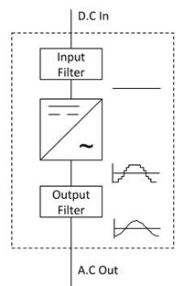

Figure 6 shows the basic components of an inverter circuit.

1. Input Filter – the input filter removes any ripple or frequency disturbances on the DC supply, to provide a clean voltage to the inverter circuit.

2. Inverter – this is the main power circuit. It is here that the dc. is converted into a multilevel PWM waveform.

3.Output Filter – the output filter removes the high-frequency components of the PWM wave, to produce a nearly sinusoidal output.

Figure 7 shows the specifications of the inverter used for the proposed design with a power requirement of 5kW, and an output supply voltage at 230 V/ 50 Hz and figure 8 shows the variation of inverter output power with respect to the PV array power .

Figure 7 : Inverter specification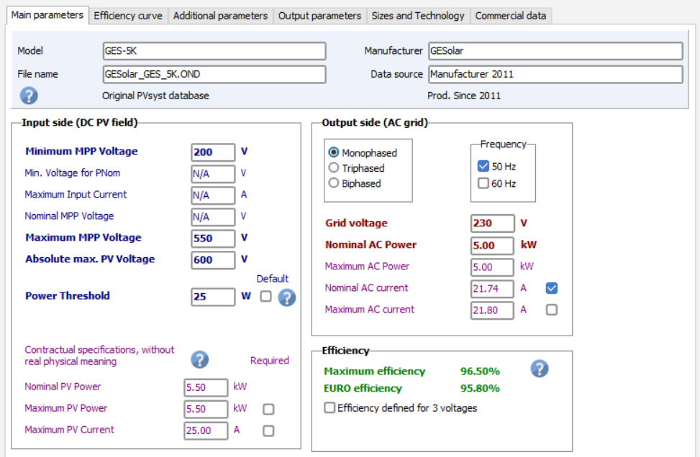



Figure 8 : Variation of inverter output power with respect to the PV array power

## 3.4 Battery Pack

Even though the PV system is grid-tied, a battery storage unit targeted for self-consumption is needed bacause:

1. Store the excess of energy generated from the PV modules so that the building consumes a minimum of energy coming from the grid.
2. Ensuring a secure back-up and ensuring electrical power availability throughout the entier day incase of a grid failure.

In self-consumption mode, the energy is stored in the battery as soon as available (i.e. when the PV production overcomes the user's needs), and is "immediately" used for satisfying the internal needs up to the battery is empty. Practically, the control device and the battery inverter is used to modulate the power, in order to exactly feed the user's consumption.

If we define:

* E_Avail: energy available after all losses behind the inverter

E_Avail = EoutInv - EAuxLss - EUnavail - EAcOhmL - ETrfLss

* E_User: internal user's needs (consumption), defined in hourly values
* E_Grid: excess PV energy, injected into the grid
* EFrGrid: back-up energy drawn from the grid
* EBatCh: the energy stored into the battery
* EBatDis: the energy drawn from the battery

We have the operating modes shown in figure 9. 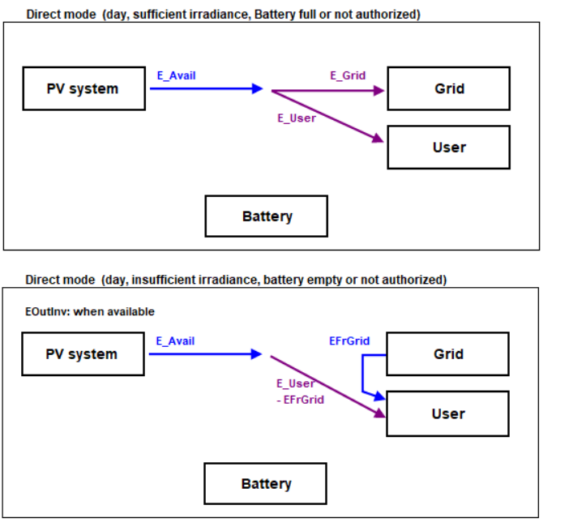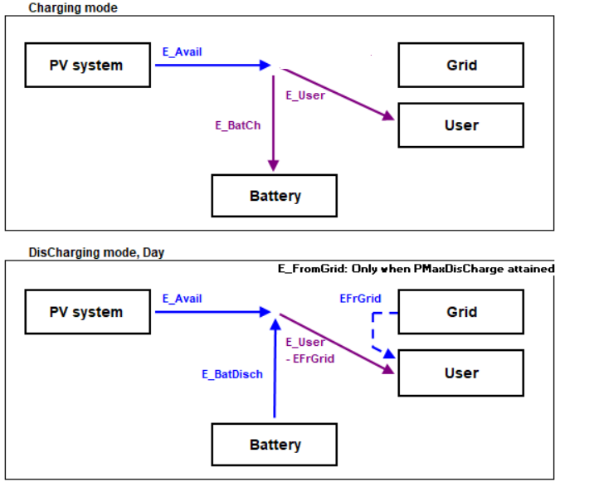

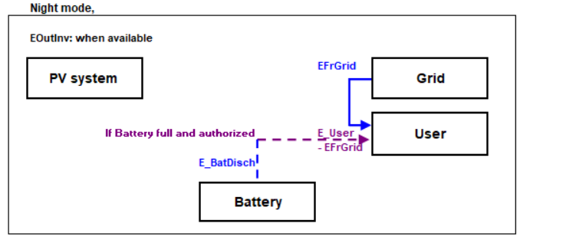

Figure 9: Battery modes of operation

Figure 10 shows the specifications of the battery used for the proposed design.

Figure 10 : Battery specifications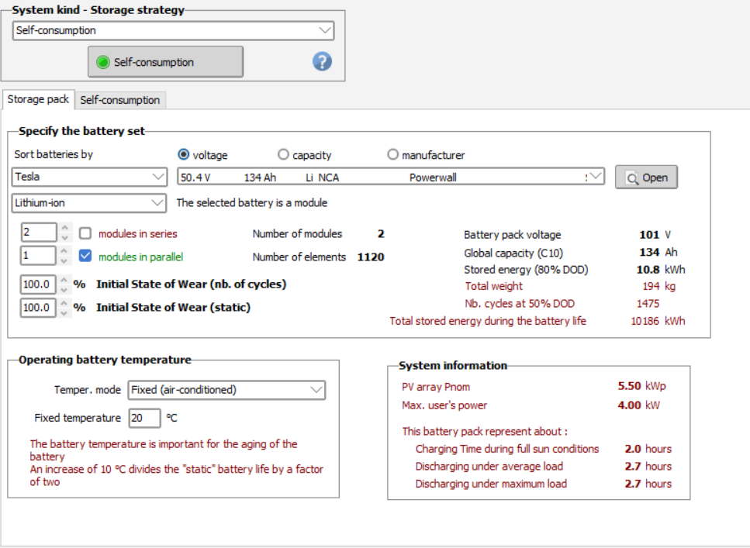

# 4. SCADA System

## 4.1 Data Acquisition

In a smart building, there are many aspects of the building’s infrastructure, from power supply, HVAC to security and analysis. Supervisory Control and Data Acquisition (SCADA) system acts as the backbone of the smart building and responsible for centralized remote control and monitoring of the buildings’ infrastructure. SCADA system can be used for the data acquisition and processing of the real-time data.

For this project Node-RED is used as a SCADA system. Node-RED is a popular flow-based programming tool that has IoT capabilities. The sensor data can be send to node-RED using mqtt. Then the data is processed inside the node-RED and generates a control signal. A common json format is used to send data to the mqtt server.

Eg:

{

time : 1666087472115

pwm_duty : 50

bt_voltage : 11.63

}

Figure 2 shows the hybrid inverter which performs all the operations inside the device itself including MPPT charge controlling, analog to digital converting etc. The hybrid inverter outputs the voltage and current readings of the PV cells and indicates the battery level of the connected li-ion battery. These readings can be sent to the SCADA system via wifi.

Figure 3 shows the basic hardware components for the actual implementation of the power supply system. The sensors and actuators are used to monitor the state of the system and send data to the SCADA system to get control decisions. There are 5 sensors for data acquisition and the data readings are sent to the SCADA system via mqtt. The SCADA system generates centralized control decisions to optimize the power supply for the smart building.

There are 2 sensors for PV cell to aquisite voltage and current readings of the PV cell current supply to monitor the state of the PV cells. If the voltage of the PV cell is not adequate (less than 10V) the battery charging is halted. The PV cell voltage and current readings are published to following mqtt topics.

326project/smartbuilding/pv/pvCurrent

326project/smartbuilding/pv/pvVoltage

The smart electric meter is used as a sensor to check the current availability of the grid and power usage of the smart building. This data is published to the following topic to decide the power source to the smart building.

326project/smartbuilding/pv/kWhmeter

To monitor the status of the battery, three sensors are used: a current sensor, a voltage sensor, and a temperature sensor. These sensor data are published to the following topics in order to monitor the battery level and determine whether or not to charge the battery with PV cells.

326project/smartbuilding/pv/battery/current

326project/smartbuilding/pv/battery/voltage

326project/smartbuilding/pv/battery/temperature

## 4.2 Network Data Communication

The hybrid inverter contains MPPT charge controllers, Battery management system (BMS), A to D converters and circuit breakers. All control decisions in a hybrid inverter are made locally by the device itself in communication with other connected components. The inverter has the following ports for connecting external components.

1. PV input port - To connect PV strings
2. Battery input port - To connect the battery
3. BMS port - To connect the BMS communication part of the battery
4. WiFi/Bluetooth port - To install the WiFi/Bluetooth communication module.
5. METER port To connect the meter.
6. ON-GRID port - To connect to the power grid.
7. DRED communication port - To connect to DRED for communication.
8. RS485 port - To connect data monitor devices.
9. BACK-UP port - To connect the BACK-UP load

The smart meter is connected to the inverter via RS-485. RS-485, also known as TIA-485 or EIA-485, is a standard defining the electrical characteristics of drivers and receivers for use in serial communications. The main advantage of using RS-485 is that it allows for long cabling distances in electrically noisy environments and it can support multiple devices on the same bus. The RS-485 or CAN bus can be connected to the BMS port to communicate between the battery management system and charge controller to monitor battery level and battery temperature. The SCADA system can receive the voltage, current, and temperature information over wifi. The centralized monitoring can be done based on the received data and the control decisions can be sent back to the hybrid inverter.

The hardware components are shown individually in Figure 3 together with the actuators. Different forms of communication between hardware components are not necessary because the SCADA system is utilized for monitoring and all the controlling. The actuators can be controlled by sending sensor data to the SCADA system and receiving control signals in return. Only MQTT is required to interact with SCADA in order to send sensor data and receive control signals to operate actuators. For MQTT connection separate circuitry with ESP8266 IC is used. The SCADA system processes the sensor data that was received over MQTT, and then sends back the control decisions to the MQTT server. The ESP8266 IC which is connected to the actuators can read the published messages through relevant subscribed topics and generate the corresponding control signals.



Figure: circuit to send sensor readings to mqtt server and receive control signals to control a relay

## 4.3 Database

**Data Retrieval**

The system has several data sources,

* Thermo meters
* Voltage Sensors ( PV_VoltageSensor, Btr_VoltageSensor)
* Current Sensors (PV_CurrentSensor , Btr_CurrentSensor)
* Switches (SW1, SW2)
* Battery state indicator
* Smart meter

Every sensor and actuator discloses their data to a public MQTT broker. It is possible to run an MQTT client on the database side to retrieve data. And then it is possible to

The table below shows the data source and what kind of data should be retrieved from the source & where do they store them

| **Data Source** | **Data & description** | **Formatted Data** | **Collection** |
| --- | --- | --- | --- |
| PV Current Sensor | Time: current time (UTC)  current: sensor value of the pv cell current sensor (float) | {  “time”:”2022-04-101T45:56:12.658Z”,  “current”:”45”  } | co326_pv_current |
| Btr Current Sensor | Time: current time (UTC)  current: sensor value of the battery current sensor(float) | {  “time”:”2022-04-101T45:56:12.658Z”,  “current”:”45”  } | co326_pv_voltage |
| PV Voltage Sensor | Time: current time (UTC)  Voltage:sensor value of the pv cell voltage sensor(float) | {  “time”:”2022-04-101T45:56:12.658Z”,  “voltage”:”45”  } | co326_pv_btr_current |
| Btr Voltage Sensor | Time: current time (UTC)  Voltage:sensor value of the battery voltage sensor (float) | {  “time”:”2022-04-101T45:56:12.658Z”,  “voltage”:”45”  } | co326_pv_btr_voltage |
| Smart meter | Time: current time (UTC)  Grid: state of grid (on/off) | {  “time”:”2022-04-101T45:56:12.658Z”,  “voltage”:”ON”  } | co326_pv_kwhmeter |
| Btr Temperature Sensor | Time: current time (UTC)  Temp: temperature sensor reading of the batter(float) | {  “time”:”2022-04-101T45:56:12.658Z”,  “Temp”: 40.1  } | co326_pv_btr_temp |
| Switch 1 | Time: current time (UTC)  Sw : state of the switch(on/off) | {  “time”:”2022-04-101T45:56:12.658Z”  “sw1”:”OFF”  } | co326_pv_sw1 |
| Switch 2 | Time: current time (UTC)  Sw : state of the switch(on/off) | {  “time”:”2022-04-101T45:56:12.658Z”,  “sw2”:”OFF”  } | co326_pv_sw2 |

There is a separate server run on the database side that has an MQTT client that subscribes to suitable topics. After retrieving data from the relevant sources, This server modified that data into the appropriate data format, added additional information, and stored the relevant collection in the database.

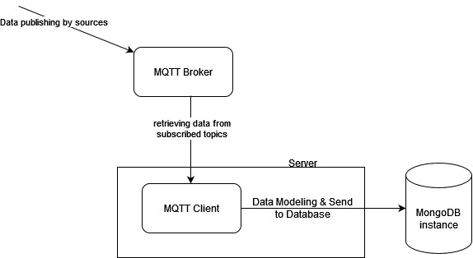

## 4.4 SCADA UI Controls

Most of the photovoltaic component management parts are done automatically based on sensor data. Though, there must be several manual controls enabling the admin user to switch the battery power consumption modes. Therefore, the design includes a feature to switch between auto and manual battery management modes. The figure below shows the UI control for manual battery management.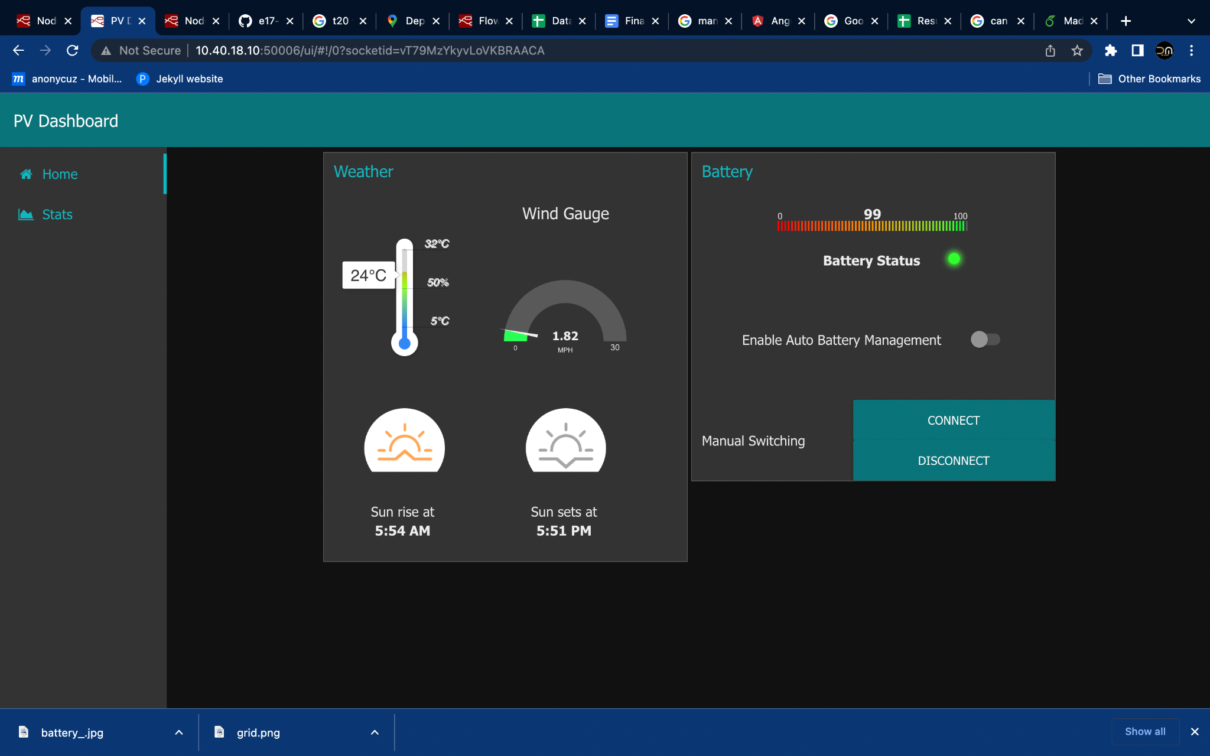

When the *Connect* or *Disconnect* button is pressed the battery management will be switched to manual mode and connect and disconnect the battery power supply to the smart building respectively. When the *Enable Auto Battery Management* switch is *ON*, the battery power supply is controlled based on the power management algorithms described in section 3.4. The UI displays the charge percentage and indicates whether the battery power supply is connected or disconnected via an *Green-Red LED indicator*.

In addition to that, SCADA UI shows the current weather conditions around the building. Primarily it displays the room temperature (related to PV panel temperature), wind speed (useful to make decisions based on natural cooling facility), sunrise and sunset times. This provides the admin to make proper decisions for PV panel maintenance.

## 4.5 Data Visualization

Each sensor in the PV system sends periodic data to the database. From the data in the database the *Data Visualization* tab displays most recent data of battery voltage levels, currents, PV panel voltage and current variation, and Battery power supply state changes as a table and a plot to get a better insight of how the system behaves in different time and conditions.

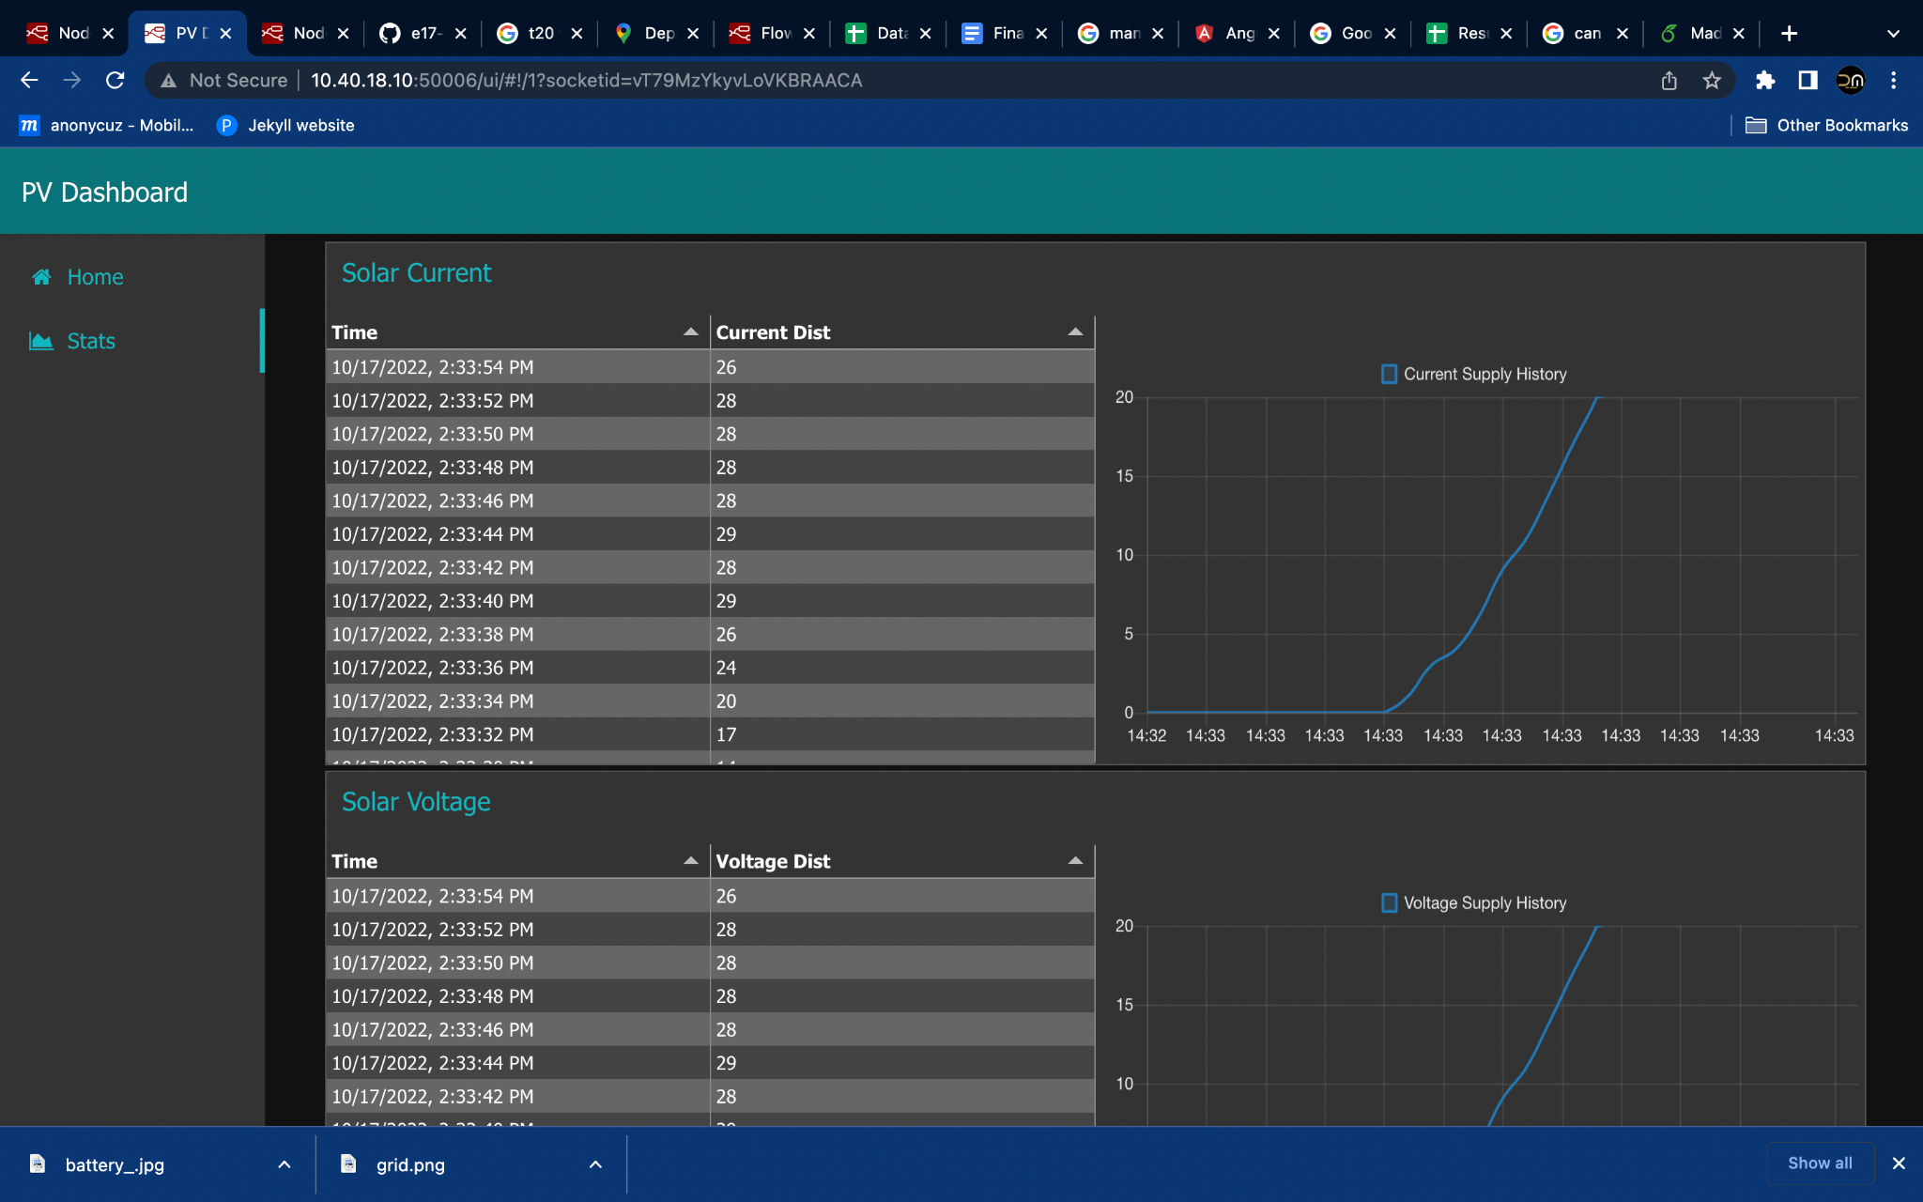

## **4.6 Data Analysis**

* We found an openly available dataset of the photovoltaic system. The dataset included weather sensor data and power generation data of the system for a period of 1 month.
* Weather sensor data (recorded against DATE_TIME):
* *Ambient temperature*.
* *PV module temperature*.
* *Solar irradiation.*
* Power generation data (recorded against DATE_TIME);
* *DC power* generated by solar cells.
* *AC power* generated after the inverter conversion of DC to AC.
* *Daily Yield*.
* This information was recorded at 15 minute intervals for a period of 1 month.
* Since we do not have enough data generated from our system for a useful analysis, we used the dataset to learn about the performance patterns and the correlation between weather sensor data and power generation data for a typical photovoltaic system.
* Source of the data set:
* <https://www.kaggle.com/datasets/anikannal/solar-power-generation-data?resource=download&select=Plant_1_Generation_Data.csv>

4.6.1 Weather sensor data.

|  |  |
| --- | --- |
|  |  |
|  |  |

4.6.2 Power Generation Data.

|  |  |
| --- | --- |
|  |  |

4.6.3 Correlation Between Weather Sensor and Power Generation Data.

|  |  |
| --- | --- |
|  |  |
|  |  |

Conclusion based on the correlation of data.

1. The transfer function between dc and ac power is linear.
2. DC power is indeed influenced by the ambient temperature, by the temperature of the module, by the irradiation and finally by the heat transfer between the module and the air. It can be concluded that ***irradiation has the highest correlation with the DC power generation*** of the photovoltaic system.
3. Inverters of Plant I lost 90% of their dc power when it was converted.

4.6.4 Predictions

* Using a simple multiple Linear Regression model, and *irradiation* and the *module temperature*as the 2 *parameters,* we were able to predict the DC power generation of the plant with a *coefficient of determination = 0.84*. In the context of Linear Regression models, this is a very good value, implying that 84% of the points fall on the predicted regression line.
* Since irradiation and module temperature are not parameters that can be measured ahead of time, trying to predict the DC power generation of a plant is not practical, instead, the above method of prediction can be used;

1. To predict the DC power generation for hypothetical values of irradiation and module temperature.
2. To measure the expected level of DC power generation, compare it with the actual DC power generation and use those results as a measure of the performance of the photovoltaic system.

Summary of Data Analysis

* For this project we used an already existing dataset to analyze the related data, and test the possibility of using correlated data to do predictions.
* These weather sensor data will most probably differ from one geographical location to another, depending on the time of the year etc.
* Moving forward with the actual implementation of the system, we can use sensors and meters to measure the same data from our system,for a given time (season) of the year, and do a similar analysis and a procedure for prediction which would give results with higher accuracy and precision.

# 5. Prototype Design and Implementation

## 5.1 Sensors

**5.1.1 Current sensor - ACS712 Current Sensor**

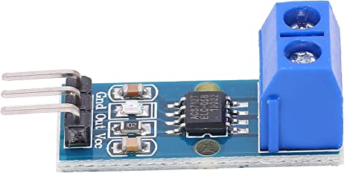

Product Description:

This sensor is connected in series nature to the AC connection, Which indicates the Current Availability in the grid. The Sensor value is read through the analog pin (A0) of ESP8266 IC. ESP8266 is connected to the Node-red Server through wifi. After processing the data itself within the ESP8266 the current availability signal is sent to the node red server via MQTT.

Advantages:

* Use the Principle of Hall effect therefore the DC components are isolated from the AC Components.
* Can be used for both AC and DC.
* Low Noise and Low Resistance.

**5.1.2 Voltage sensor - ZMPT101B Voltage Sensor**

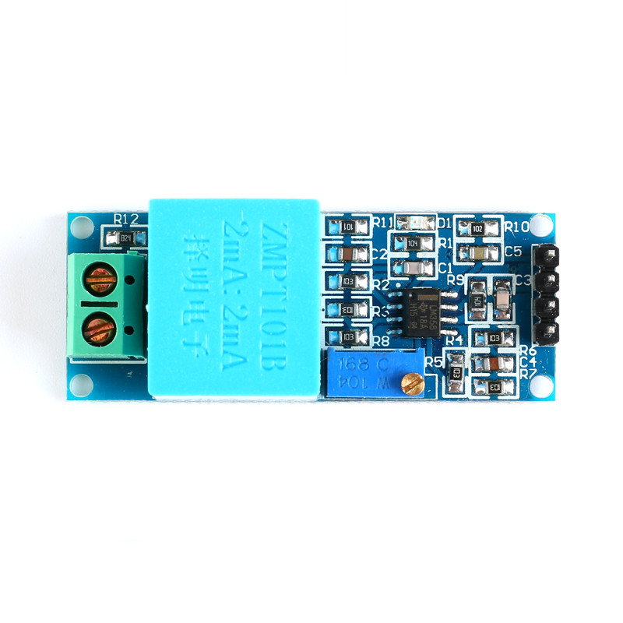

Product Description:

The ZMPT101B is a single-phase Alternating Current (AC) voltage sensor module. This module includes an on-board voltage transformer that performs the function of galvanic isolation, supports up to 250 Vac input voltages and delivers through its output terminal an analog sine wave with adjustable amplitude by using the on-board potentiometer. This module could be used together with a current transformer to measure power consumption.

Specifications:

* Input signal voltage: up to 250VAC
* Supply Voltage: 3.3-5V
* Output signal: 0-5V
* Size: 50 x 20mm

## 5.2 Actuators

**5.2.1 Relay - 5V Single-Channel Relay Module**

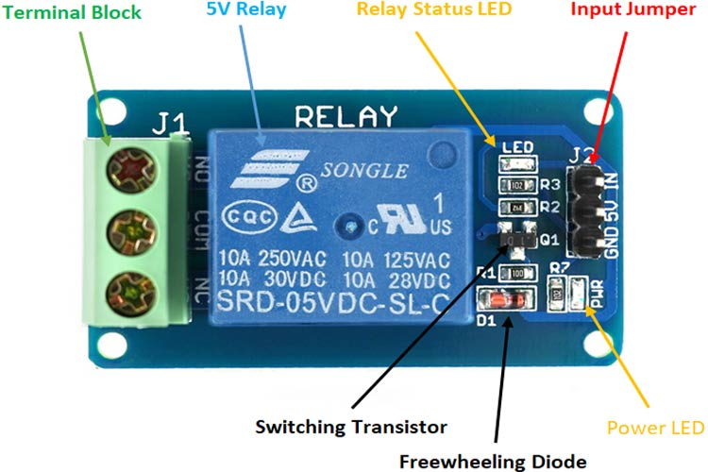

Relay is an electromechanical device that uses an electric current to open or close the contacts of a switch.

Product Description:

| **Pin Name** | **Description** |
| --- | --- |
| IN | Input (control signal) to activate the relay |
| 5V (VCC) | Supply input for powering the relay coil |
| GND | 0V reference |
| NO (normally open) | Normally open terminal of the relay |
| NC (normally closed) | Normally closed contact of the relay |
| COM (common) | Common terminal of the relay |

The single-channel relay module contains components that make switching and connection easier and act as indicators to show if the module is powered and if the relay is active.

First is the screw terminal block, which is the part of the module that is in contact with AC. Adding screw terminals makes it easier to connect thick mains cables. The three connections on the terminal block are connected to the normally open, normally closed, and common terminals of the relay.

The second is the relay itself. Lots of information can be gleaned from the markings on the relay itself. The part number of the relay on the bottom says “05VDC”, which means that the relay coil is activated at 5V minimum – any voltage lower than this **will not be able to reliably close the contacts of the relay**. There are also voltage and current markings, which represent the maximum voltage and current which the relay can switch. For example, the top left marking says “10A 250VAC”, which means the relay can switch a maximum load of 10A when connected to a 250V mains circuit. The bottom left rating says “10A 30VDC”, meaning the relay can switch a maximum current of 10A DC before the contacts get damaged.

The 'relay status LED' turns on whenever the relay is active and provides an indication of current flowing through the relay coil.

The input jumper is used to supply power to the relay coil and LEDs. The jumper also has the input pin, which when pulled high activates the relay.

The switching transistor takes an input that cannot supply enough current to directly drive the relay coil and amplifies it using the supply voltage to drive the relay coil. This way, the input can be driven from a microcontroller or sensor output. The freewheeling diode prevents voltage spikes when the relay is switched off.

The power LED is connected to VCC and turns on whenever the module is powered.

Single-Channel Relay Module Specifications:

* Supply voltage - 3.7V to 6V
* Quiescent current: 2mA
* Current when the relay is active: ~70mA
* Relay maximum contact voltage - 250VAC or 30VDC
* Relay maximum current - 10A

Advantages of using relays:

* The current required to activate the relay is much smaller than the current that relay contacts are capable of switching.
* The coil and the contacts are galvanically isolated, meaning there is no electrical connection between them.
* The relay can be used to switch mains current through an isolated low voltage digital system like a microcontroller.

### 

Internal Circuit Diagram for Single Channel Relay Module:

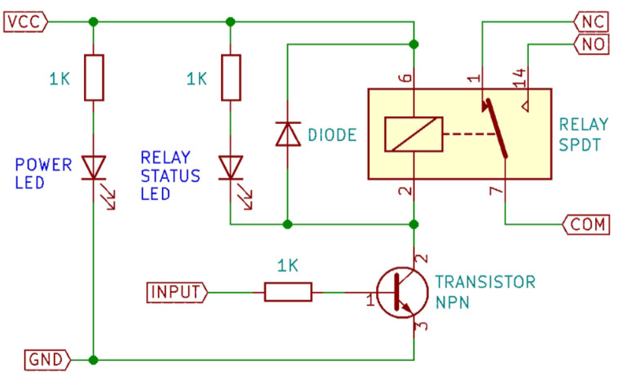

## 5.3 Battery Pack Simulation

We had to develop a simulation of the battery pack due to the project's timeframe and budget constraints. Simulating a battery is not an easy task. Therefore, we had to simplify various parameters in order to do that. The simulation is implemented using Python. It has four threads running in parallel to react and take actions in near real-time. The four threads are for the following purposes,

1. Mimic the loading of the battery by iteratively consuming power from the battery.
2. Listen to the SW1 MQTT topic (which controls the charging of the battery). This thread sets the charging power of the battery according to the PWM duty cycle returned from the SW1 messages.
3. Listen to the SW2 MQTT topic (which controls whether the home appliances are connected to the grid or to the battery). This thread decides whether to start the Thread 1 (that simulates the loading of the battery) or put it to sleep according to the SW2’s action returned.
4. Mimic the charging of the battery, and publish the battery stats to the MQTT server.

The threads 2, 3, and 4 has their own MQTT clients. The battery is implemented as a Python object so that it makes easier to customize the parameters.It has the attributes SoC (State of Charge of the battery) and Voc (open-circuit voltage of the battery) that keeps track of the battery’s charge state. The charging power and battery capacity are also kept as attributes. Charging takes place according to the charging power which can be set dynamically. To make the battery voltages more realistic, we found a mapping of SoC to the open circuit voltages of a 12V lead acid battery. We interpolated the mapping so that we have more data points to look up (using a look up table) for a given SoC value. The charging of the battery is as follows,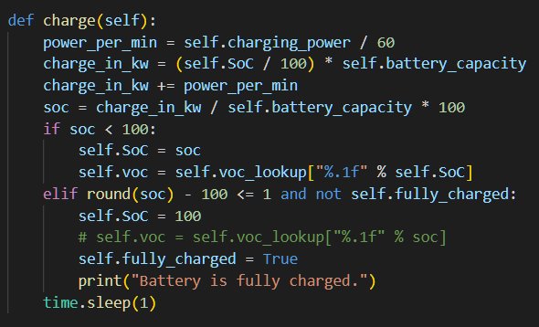

A second in real-time is made to be a minute in simulated time to ease the process of analyzing the operation. A similar method is followed to simulate the loading of the battery given a loading power.

## 5.4 Implementation of Charge Controller

A solar charge controller, sometimes referred to as a solar regulator, is essentially an electrical device that connects a battery to solar panels. Its responsibility is to control the battery charging procedure and guarantee that the battery is correctly charged—or, more crucially, not overcharged. Most small-scale off-grid solar power systems use DC-coupled solar charge controllers, which have been in use for many years.

For this project, we decided to use a PWM charge controller instead of using MPPT, since it is the low-cost option and suits for a small 12V system. PWM charge controllers have a direct connection from the PV array to the battery and use a basic ‘rapid switch’ to modulate the battery charging. In this method, the solar panel voltage is pulled down to match the battery voltage. This in turn pulls the panel voltage away from its optimum operating voltage and reduces the panel power output and operating efficiency.

Due to the limitation of the budget constraints, we decided to implement a PWM charge controller logically through SCADA instead of buying a charge controller module or implementing from scratch. Before the implementation we found out about multi-stage charging which is an application of specific controlled charging stages intended to maximize battery charge, health and life-span. The whole process of multi-stage charging is demonstrated in the following diagram,

**Bulk charging stage**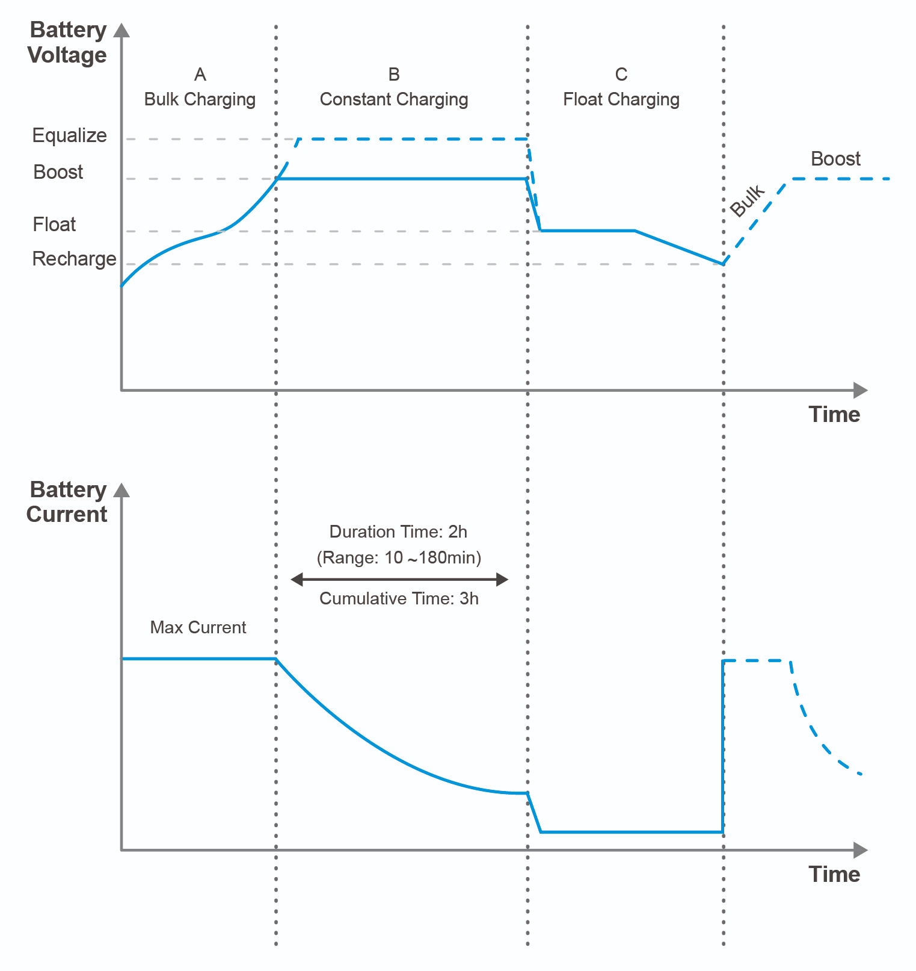

In Bulk charging, the charger tries to put as much charge current into the battery as possible. It is generally the same as constant current charging. Nearly 80% of battery charging takes place in the bulk stage.

**Absorption Stage**

As a battery takes charge, its voltage rises. When the voltage hits a predetermined absorb setpoint, the charger will switch into the absorb stage. In the absorb stage, the charger output voltage is held constant at the absorb voltage. This is known as constant voltage charging. Charge current will slowly decay from the peak during bulk dow to a low level. The absorb stage is completed when the charging current drops to a predetermined level. The absorption stage is controlled by a parameter called absorb time which should be predetermined by the battery manufacturer. Absorb stage will bring the battery to 95% state of charge.

**Float Stage**

After completion of the absorption stage, the multi stage charger will switch to float charging. This is also constant voltage charging but the voltage is lower than the absorption voltage. Float is sometimes called trickle charging. The charge current is very low. Float charge brings the battery up the last few % to 100%. A battery can be left on float charge.

We have implemented the above 3-stage charges in our logical PWM charge controller in a simplified manner,

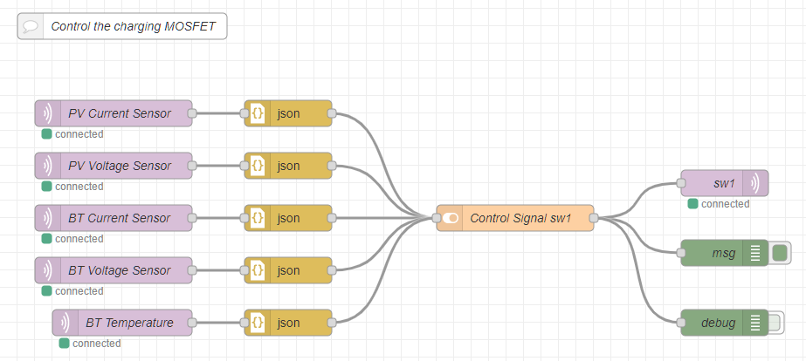

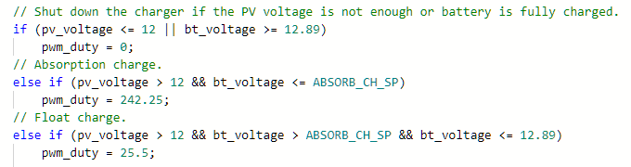

# 

# 

# 

We have ignored the bulk charging stage due to the simplicity so that we only have constant voltage charging stages. The MOSFET switch SW1 is switched using PWM signals via the MCU. The charge controller senses the PV voltage and the battery voltage in order to determine the charging stage.

# 

# 

# 6. References

* Photovoltaic European Technology & Innovation Platform “Assessing the need for better forecasting and observability of PV”, 2017.
* S. Vergura, “Big data and efficiency of PV plants”, 20th IMEKO TC4 International Symposium, Benevento, Italy, September 15-17, 2014.
* E.Koubli, D.Palmer, T.T. Betts R. Gottschalg. “Assessment of PV system performance with incomplete monitoring data”, 31st EU-PVSEC, Hamburg, pp.1594-1597, 2015.
* X Y Li, “Degradation analysis of photovoltaic modules based on operational data: effect of seasonal pattern and sensor drifting”, International Conference on New Energy and Future Energy system NEFES, 2016.
* Julian Ascencio-Vasquez, “An Overall Data Analysis Methodology for PV Energy Systems”. 53rd International Conference on Microelectronics, Devices and Materials, Ljubljana, Slovenia
* *“Hardware Implementation of DC-DC Converter for MPPT in PV Applications.” Hardware Implementation of DC-DC Converter for MPPT in PV Applications.*
* “Control and Management of Solar PV Grid Using Scada System.” Control and Management of Solar PV Grid Using Scada System.
* <https://www.youtube.com/watch?v=K12l9J3pLIU>
* <https://www.inspirecleanenergy.com/blog/sustainable-living/measuring-your-state-of-charge>
* <https://www.youtube.com/watch?v=IPEgZGBTjv8>
* <https://www.leonics.com/support/article2_14j/articles2_14j_en.php#:~:text=MPPT%20checks%20output%20of%20PV,connected%20directly%20to%20the%20battery>.
* <https://www.ti.com/lit/ug/tiduej8a/tiduej8a.pdf?ts=1665980392608&ref_url=https%253A%252F%252Fwww.google.com%252F>
* [Variation of Voc against SoC of a lead acid battery](https://footprinthero.com/lead-acid-battery-voltage-charts)